Portfolio Project: Final

Mahgan (Mae) McCreary
Colorado State University Global
CSC450: Programming 3
Prof. Herbert Pensado
April 5th, 2026

Portfolio Project: Final

C++ Code

Pseudocode
#include <thread>
#include <mutex>
#include <iostream>
#include <chrono>

Std::mutex m;
Int counter = 0;
Void t1() { //count up from 0
For (int i = 0; i < =20; ++i) {
{
std::lock_guard<std::mutex> lock(m);
Counter = i;
Std::cout << “t1: “ << counter << “\n”;
} //mutex unlocks here automatically (out of scope)
std::this_thread::sleep_for(std::chrono::milliseconds(50)); //pause for gradual counting
}
}
Void t2() {
For (int i = 20; i >= 0; - -i) {
{
std::lock_guard<std::mutex> lock(m);
Counter = i;
Std::cout << “t2: “ << counter << “\n”;
} //mutex unlocks here automatically (out of scope)
std::this_thread::sleep_for(std::chrono::milliseconds(50)); //pause for gradual counting
}
Int main () {
Std::thread a(t1);
a.join(); //waits until t1 finishes
Std::thread b(t2);
b.join(); //waits until t2 finishes before exit
Return 0;
}

Source Code
#include <iostream>
#include <thread>
#include <mutex>
#include <chrono>
std::mutex m;
int counter = 0;
void t1() { //count up from 0
for (int i = 0; i <=20; ++i) {
{std::lock_guard<std::mutex> lock(m);
counter = i;
std::cout << "t1: " << counter << "\n";
} //mutex unlock here automatically (out of scope)
std::this_thread::sleep_for(std::chrono::milliseconds(50)); //pause for gradual counting
}
}
void t2() {
for (int i = 20; i >= 0; --i) {
{std::lock_guard<std::mutex> lock(m);
counter = i;
std::cout << "t2: " << counter << "\n";
} //mutex unlock here automatically (out of scope)
std::this_thread::sleep_for(std::chrono::milliseconds(50)); //pause for gradual counting
}
}
int main() {
std::thread a(t1);
a.join(); //waits until t1 finishes
std::thread b(t2);
b.join(); //waits until t2 finishes to exit
return 0;
}

Screenshots
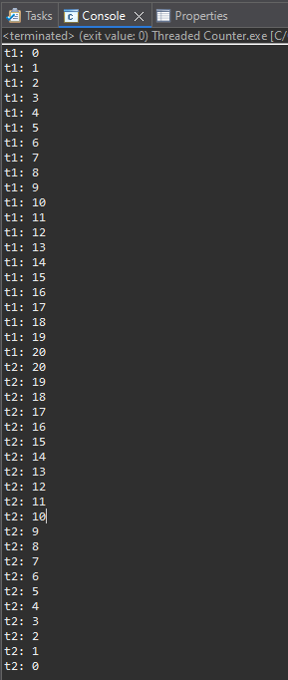

Java Code

Pseudocode
Public class ThreadedCounter {
Static void sleep() { //pauses thread for count
Try {
Thread.sleep(50);
} catch (InterruptedException e ) {
Thread.currentThread().interrupt(); //re-sets interrupt flag
}
}

Public static void main (String[] args) throws InterruptedException {
Thread t1 = new Thread(() → {
For (int i = 0; i <= 20; ++i) {
System.out.println(“t1: “ + i);
sleep();
}
});
Thread t2 = new Thread (() → {
For (int i = 20; i >= 0; –i) {
System.out.println(“t2: “ + i);
sleep();
}
});
t1.start();
t1.join();
t2.start()
t2.join()
}
}

Sourcecode
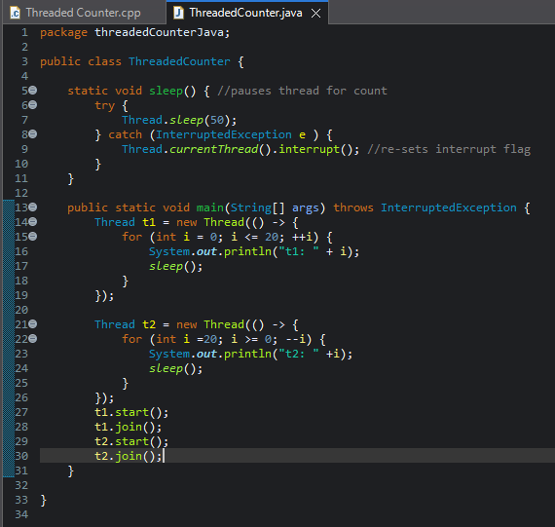

Screenshots
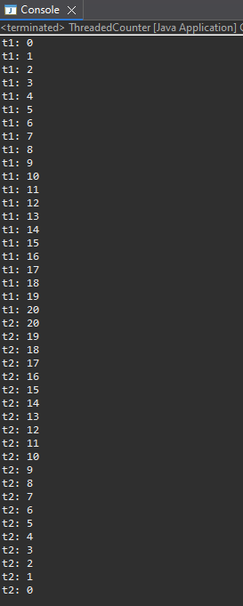

Code Analysis
Multithreading allows for the development of programs that utilize concurrency. It involves breaking code down into small units of execution (sort of like a method) called threads. With this additional functionality comes a range of new challenges and issues to contend with due to the nature of threads. Concurrency involves the coordinated, rapid switching between tasks to give the appearance of simultaneous execution without fully dipping into parallelism.
Two of the most common issues to come across when using concurrency are race conditions and deadlocks. Race conditions happen when two or more threads access the same bit of data and at least one of them makes changes to said data; this can lead a program to behave unexpectedly while still appearing to run normally outside of an unexpected output. The other fairly common major issue with concurrency is deadlock, wherein two or more threads seek multiple shared resources in a different order. This can cause each thread to snap up one of the needed resources and leave both forever waiting for the resource the other thread has already taken to be released, bringing the entire program execution to a standstill.
When it comes to strings in C++, there are also some significant vulnerabilities to watch out for; the seemingly worst one is Format String Vulnerability. This vulnerability seems the most serious due to the number of issues it can cause and the relative ease with which this mistake can be made. This occurs when a variable is passed to a print function directly, rather than properly using a format string. In the case that this variable is pre-determined, set, and doesn’t include any format specifiers, it might not necessarily cause any issues. If, on the other hand, this is a user-defined variable that gets passed directly, then the user can take advantage of that and inject commands into the variable, which could aid in a DDoS attack, privilege escalation, or even just crash the system.
Given the simplicity of this code, the fact that it doesn’t accept any user input, and the fact that the primary primitive data type exhibited in my code is integers, I’m not aware of many particular security issues aside from Integer Overflow and Underflow, both of which happen when trying to assign an integer a value outside of its range. In the above code, it is far from being an issue as 0-20 are well within the acceptable range for an integer.
When comparing C++ and Java, the first thing to note is their different levels of complexity; both are powerful high-level coding languages, but they have different trade-offs. C++ is lower level than Java (in that it operates closer to the hardware) and gives the user incredible power and freedom at the cost of built-in security. Because C++ operates closer to the hardware without properly structured and secured code, any existing vulnerabilities could easily be leveraged by an attacker to gain deeper control of the system. Java, conversely, has more security controls baked in, giving developers a little less freedom and power in exchange for not having to worry as much about memory exploits. Additionally, in Java, memory is managed, arrays are bound checked, and there are no format-string issues. Though format string issues may not be a problem in Java, the immutability of Java strings makes them less than ideal for storing sensitive or secret information; once set, the string cannot be changed, is often copied, and can show up in reports and logs. In C++, however, strings are mutable, though that doesn’t guarantee safety because copies happen just as easily, and just because something in memory has been freed doesn’t mean it has been erased or overwritten.
In terms of security, the code snippets included here are comparable because both avoid any major pitfalls or potential weaknesses of their languages. More care would have to be taken for input checking if either program accepts user input. If the programs did accept user input, I would say that Java would be the more secure of the two because of its lack of format string issues, though that doesn’t mean that Java is immune to issues with unchecked user input. Between the two, I am most familiar with and have worked the most with Java, but given the option, I’d opt to use C++, not despite its weaknesses but because of them. Though it may be more difficult to make my programs work, given my lack of experience and increased stumbling blocks, the increased level of care and attention that writing in C++ requires would contribute significantly more to the growth of my coding skills.

References
GeeksforGeeks. (2025a, October 30). Synchronization in Java.
https://www.geeksforgeeks.org/java/synchronization-in-java/
GeeksforGeeks. (2025b, December 13). Java threads.
https://www.geeksforgeeks.org/java/java-threads/
GeeksforGeeks. (2026, March 5). Multithreading in C++.
https://www.geeksforgeeks.org/cpp/multithreading-in-cpp/
Klusáček, J. (2024, October 21). Format string vulnerability. Hacking Lab.
https://hackinglab.cz/en/blog/format-string-vulnerability/
Ricciardi, A. (2024, October 12). Understanding C++ data types, vulnerabilities, and key
differences with java. Omegapy. https://www.alexomegapy.com/post/understanding-c-data-types-vulnerabilities-and-key-differences-with-java
Ricciardi, A. S. (2024, November 10). Concurrency in C++: Mitigating risks. Medium.
https://levelup.gitconnected.com/concurrency-in-c-mitigating-risks-5891fba59842

